**Restaurant Management**

In this restaurant, it consists of restaurant ID, Name and location, and this restaurant consists of many branches and owns by owner. There are employees work in the restaurant and manages each branch. Many dishes are provided in the restaurant that are ordered by customers. Each branch consists of branch id, location, phone number, number of employees. Every employee has unique id, name and their role. Owner consists of name and phone number. Order consists of Order number, time for deliver, payment and can be offline and online. Customer can register with the restaurant website through online and make payments and consists of customer id, phone number, password, mail id.

Attributes and entities:

Restaurant – restaurant_id, name, location

Owner – Id, name, phone_number

Customer – Customer_id, phone_number, password, mail_id

Order – order_id, time, payment

Branch – branch_id, location, phone_number

I am comparing the above proposal with the KFC and its sales in 2021 was $13.1 million. 8,20,000 employees currently working in KFC.

Client server architecture:

The data is stored in a central server and everything is connected with the internet access. The restaurant server holds the order and customer details. Customer orders the order and pays the bill and food is prepared and delivered to customer.

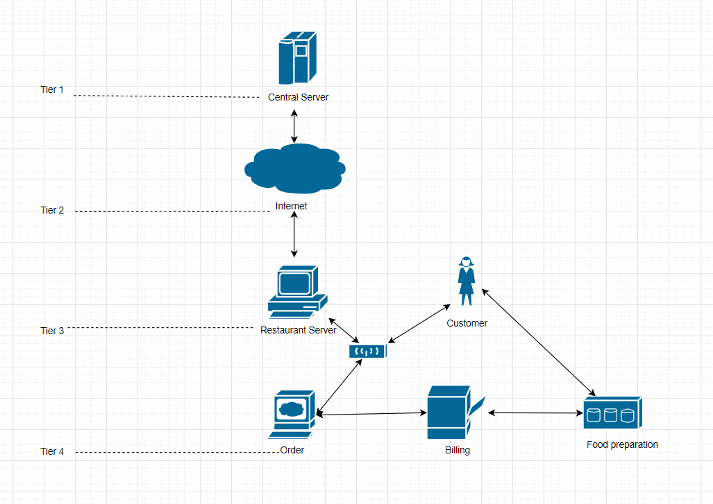

What kind of tool did we mention in class that performs data translations from one system to another?

Xampp

Name FIVE current examples of that tool, and provide the URL where you found the information.

WordPress, Facebook, OpenSSL, MySQL, FileZilla FTP Server

Name three common data formats that computer systems use to transfer product data between systems.

JSON, XML, HTTP

References:

<https://www.snb-t.com/wp-content/uploads/2022/03/2021-KFC-Annual-Report.pdf>

<https://www.zippia.com/kfc-careers-28614/demographics/>

<https://blog.udemy.com/xampp-tutorial/>